AS/PC Complete – New Look – Improved Functionality

*We have given instructions or pictures for most recent changes. If you have questions about other items, please give our Technical Support team a call at 610-820-0440 – Option 1 or open at ticket from Help/ Open Support Ticket within the program or simply here to get* [Epic Support - for your Practice Management Software](http://dbconsultants.com/epic-support-for-chiro-software/)

Main Menu Toolbar

We’ve redesigned our main menu Toolbar significantly. Gone are the icons with no description that may have left new users wondering where to go. These have been replaced with more modern icons and tags that give a clear indication of what each item represents.

Out with the OLD:

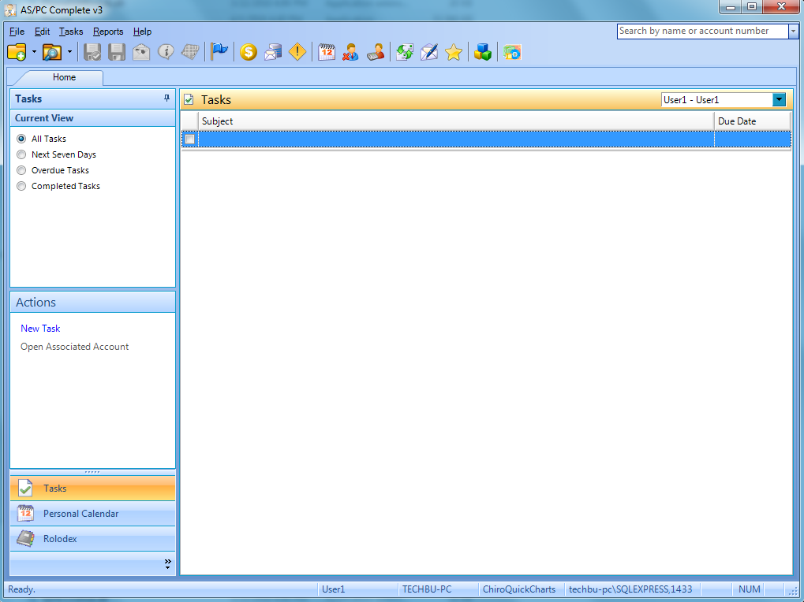

And in with the NEW:

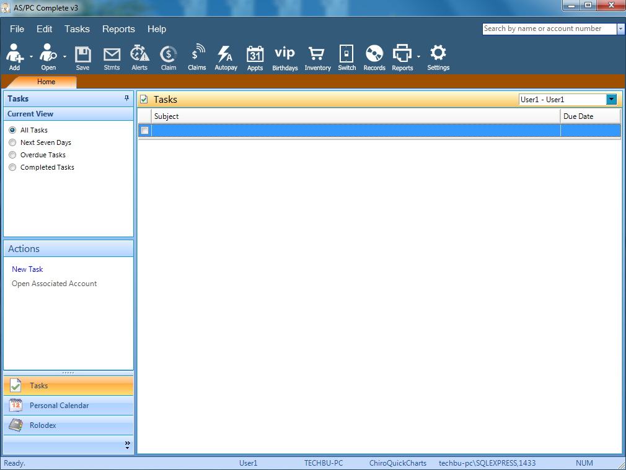

* + - File / Edit / Tasks / Reports / Help menus have not changed.
    - New Icon Definitions:
      * Add – Adds a new patient, case or prospect record
      * Open – opens a recent patient record or permits search for patient
      * Save – Save’s current patient’s record
      * Stmts – for current patient, generates statement of user’s choice with a multitude of options.
      * Alerts – manage alerts for current patient
      * Claim – generate a claim for current patient
      * Claims – batch claims for selected patients
      * Autopay – batch posting of electronic EOB’s for patients from ANSI 835 files
      * Appts – opens scheduler
      * Birthdays – process batch letters, list or labels of patients whose birthdays match defined parameters
      * Inventory – keep track of what you have in stock and from whom you order.
      * Switch – Toggle between the PM and the EHR (if you have both programs)
      * Records – manage records/images retained for individual patients
      * Reports – source of your management and productivity reports and rebilling claims.
      * Settings – quick access to all of your options.

Scheduler

* + Added validation for scheduling appointments if no date/time has been selected. (Error appeared mid-development the plan implementation from this build).
  + Added ability to display case type name to scheduler preview block (**defaulted to not** display, so the interface stays the same until the user activates it in the Settings->Appointment Customization window)
  + Added passing of currently opened patient file when Scheduler opened so that the person can just go ahead and create appointments for that person.
  + Added field “Reminder Sent” to the window. This box will be filled when auto reminders are sent.  
    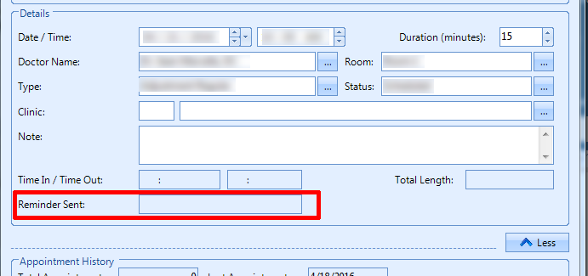
  + Add/Edit Appoinment Window: Updated Tab order of entry boxes.
  + Appointment Status Code Lookup: Added checkbox to enable/disable appointment reminders to be sent for specific status code types.

Report Re-design

* + Daysheet changes
    - On Summary section, if there is a difference of PPA and PPX transactions for the date range selected, new items under the Insurance Payments and/or Patient Payments sections will appear called “Net Patient/Insurance Reconciled Payments. (This difference results when applying unassigned payments from one Doctor/Clinic to different Doctor/Clinic)
    - Daysheet: Updated to allow cpt code up to 12 characters long.
    - Daysheet: Expanded doctor box at the bottom so long names don’t word wrap.
  + Outstanding Claims Report:
* Changed field of “Policy No: “ to “Pol#/ID:” and now show both Policy No and Insured ID or the word “None”
* Added ability to filter on Insurance Type and to choose between Starting account or Single Account (drop down).

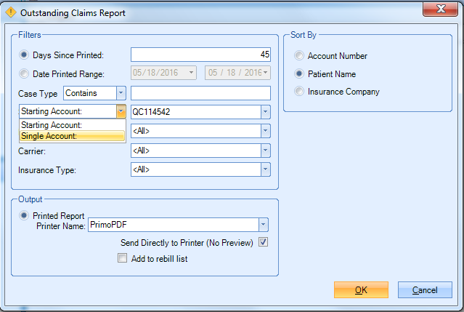

* Office Stats Report:
  + - Updated “Visits by Provider” label to “Visits by Case Provider”
    - Fixed calculations to include user-defined payment actiontypes that increase the patient/insurance balances.
    - Updated processing to include Clinic = 0 transactions (was evaluating for null Clinic).
  + Aging Report: Added Insurance Type so that Aging can be done by Insurance Type listing.
  + Audit/Supervisor Logs:
    - Added log entries for changes to doctor file.
    - Continued work on Audit/Supervisor log entries for modifications to PatientCase DX, Patient Notes and Patient Image on right side of patient file (near checklists). (Charges/Payments still to do, as well as many more).
    - Supervisor Log Window: Added toolbar button to save supervisor log to excel file.  
      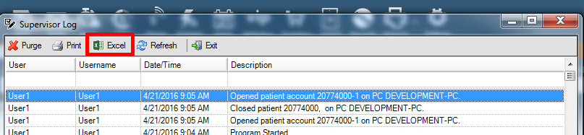
    - Continued work on Audit/Supervisor entries for updates to Patient and PatientCase.
    - Added recording changes of fields (First Name, Middle Initial, Last Name, Primary Address Line 1, Primary Address Line 2, City, State, Zip, Primary Phone, Home Phone, Cell Phone, Address To Use For Communications, Alternate ID, DOB). Still tons more to add.

Patient Tab

* Added ability to see inactive patient cases in open patient file window if Active Only is unchecked.
* Open Patient File: Expanded ability to search on a number of fields including:

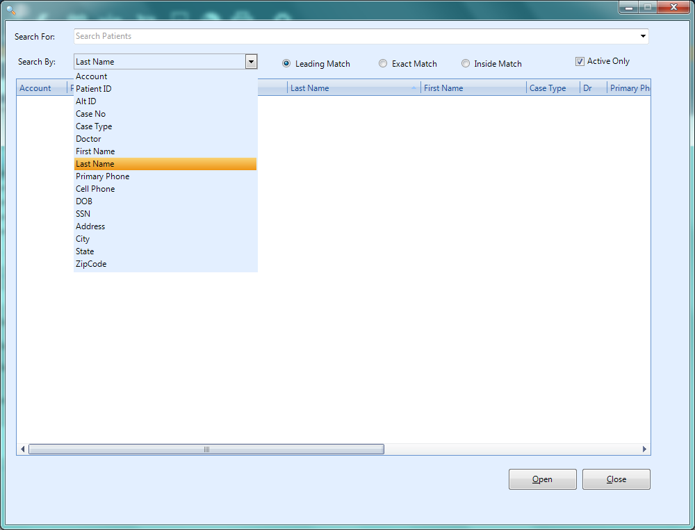

* + - Choose whether you want last payment amounts/dates updated for patient and/or insurance payments. Set this on the ledger page of User Options:   
      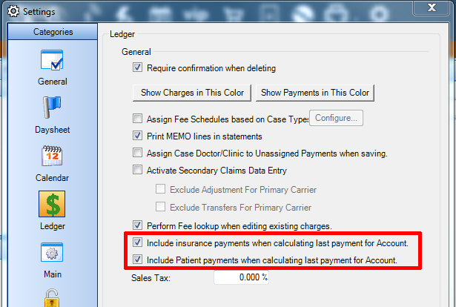
    - Patient Image: Added button to allow clearing of Patient Image.  
      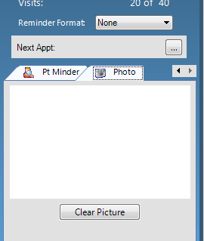
    - Added tooltip when creating a new case to inform user that they MUST select a Doctor/Clinic.
    - When adding a new case and closing the patient file without saving, added message to ask if the user would like to save or cancel the close patient file process.
    - Added totaling for balance columns of grid.
    - Added field for Patient Nickname on Patient Tab.

Charges Tab

* Updated shortcut key for “Tagged” checkbox (now called “Billed”) to Ctrl-B instead of Ctrl-T.
* Updated process when saving charge that has payments already made to it, to flush any change to FeeID to the payments as well.
* Updated Charge Entry FeeCode/QuickCode dropdown to use Fee ID rather than FeeCode/QuickCode for the basis of its storage.
* Charge Entry Grid: Added column FeeID.

Payments Tab

* Updated Payments to obtain FeeID from their associated charge.
* Updated Reconcile tool payments to set FeeID to the charge FeeID.
* Added Insurance Paid checkbox field on posting/payments grid to show/calculate when adding transactions when the INSURANCE PORTION of a service line is completely reconciled.
* ActionTypes: Added new actiontypes for adding adjustments against the legacy AS/PC balances:  
  - CONVICR: Conversion Insurance Credit.  
  - CONVIDE: Conversion Insurance Debit.  
  - CONVPCR: Conversion Patient Credit.  
  - CONVPDE: Conversion Patient Debit.

Cases Tab

* + - Added 3 new columns for Patient Balance, Insurance Balance, and Total Balance for each of the cases listed.  
      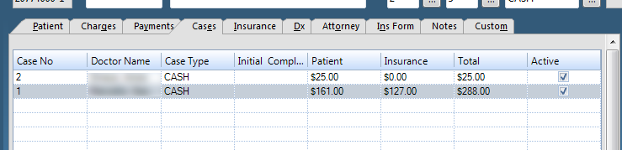
    - Added ability to hide/show columns of Cases Grid like the Charges/Payments Grids.  
      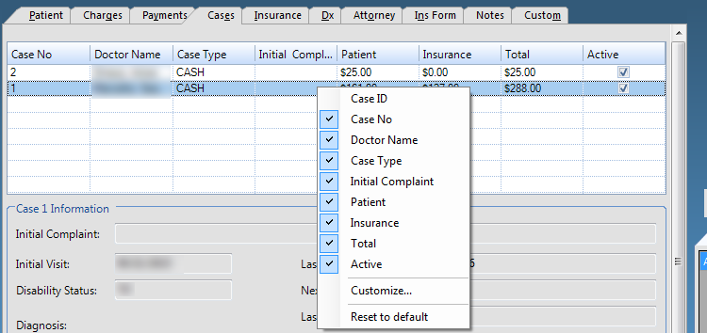

Insurance Tab

* Insurance Type Lookup: Added checks to ensure that Insurance Types are unique (no duplicate Type fields).
* Insurance Type Lookup: Updated Refreshing of Insurance Company/Insurance Type lookups. So that the grids will refresh after InsuranceType information is modified.

Notes Tab

* Updated F3 keypress on Notes Tab to produce entry in the format:   
  ID: [PatientID]-1; Chart [EMRAccount]-1: [FirstName] [LastName] [Timestamp] [UserName]

Patient Statement Topics

* Statement with DX: Updated to have modifiers separated by Hyphens included on Statement with DX.
* Added Statement type “Patient Balance Statement” that shows with the same format as Explanation of patient balance. This statement now has a header design to match regular statement designs.
* Updated statements to allow CPT code up to 12 characters long.

Claims Processing

* Updated Insurance Company Filter grids to grey (disabled) background when All Carriers radio button selected or white(enabled) if not.
* Updated Case Type Filter grids to grey (disabled) background when All Carriers radio button selected or white (enabled) if not.

Medicare Part A Billing:

* Part A Claims: Updated value codes of 50,51,52 to not autopopulate values of 0, if that type of visit (I.e. no charges with the appropriate revenue code exist) doesn’t exist within the billing timeframe.
* Part A: Updated 5010 HI segments to try to load value codes (50,51,52) from revenue codes from the service lines before filling with data from the UB-04 manually entered data.
* Part A: Set value code A3 to always appear containing the total claim amount.
* Part A Claims: Added ValueCodeType table to store the available value codes for Part A claims and if they are considered a decimal or integer value.
* Part A Data Entry: Updated Adding/Editing Value Codes to restrict entry box to decimal or integer based formatting based upon the selected value code.
* Part A: Updated Patient Status Code, Admission Type, and Admission Source elements (CL101,CL102,CL103) to fill with defaults (30, 3, 1 respectively) if not entered by the user on UB04 data entry section.
* 5010 Part A: Updated 5010 processing to show decimal value or integer value based upon the definition of the value code in the ValueCodeType table.

Miscellaneous Items

* Autopay: Updated to set ServiceDate field of transactions created.



* Tasks->Labels & Envelopes: Added dropdown to allow selection of address to use: Default (PatientCase setting), Primary, Secondary, Care of.
* Address Labels: Fixed Patient Address Labels, not Using the address to use selected in the statement wizard or the patient case.
* Tasks Menu: Added Tasks -> Admin -> Show Legacy AS/PC Balances to provide interface to see Legacy AS/PC Insurance and Patient Balances.
* EMR Charge Import Process: Added setting of ServiceDate field in Posting when charges imported.
* User Options: Added option for performing fee lookup when editing existing charge. Defaults to Checked.  
  